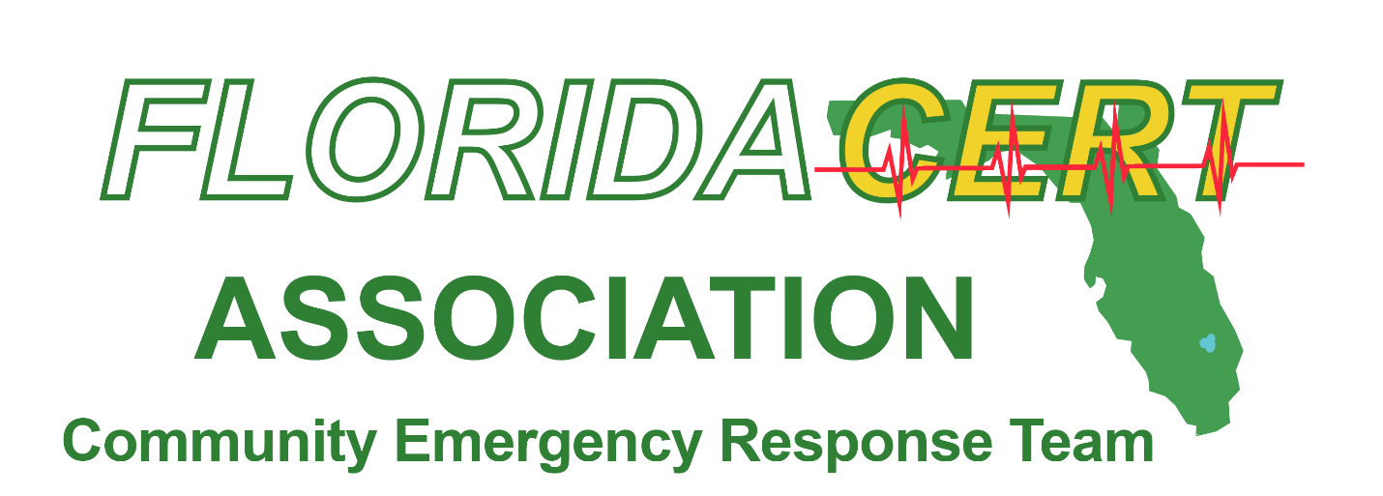

The Westin Cape Coral Resort at Marina Village  
5951 Silver King Blvd.  
Cape Coral, FL 33914

August 13-16, 2025

*2025 Sponsor Packages*

We are very excited about the promotional opportunities available at the Twenty-Second Annual 2025 Florida CERT Association State Conference in Cape Coral, Florida from August 13-16, 2025. You will have the opportunity to showcase your products and services to CERT Program Managers, CERT Instructors/Trainers and other Emergency Management Professionals at this Conference.

As many of the CERT programs are sponsored by a public safety agency such as fire, law enforcement and emergency management, your participation in this event will connect you with industry decision makers and give your company exposure to these organizations. As the Florida CERT Association is a 501(c)(3) Corporation, your sponsorship fee will be tax-deductible.

CERT Conference participants are always excited to visit with exhibitors during the Conference. We invite you to review our promotional opportunities and choose the one that is right for you.

If you have any questions, please do not hesitate to contact us:

Email: [Info@FlaCERTassociation.org](mailto:Info@FlaCERTassociation.org)  
 Bruce Caruso: 954-547-2245 - [VP@flacertassociation.org](mailto:VP@flacertassociation.org)

Mario Valle: 239-825-6486- [MValle@pbscontractors.com](mailto:MValle@pbscontractors.com)

Justin Powell: 850-687-6868 – [president@flacertassociation.org](mailto:president@flacertassociation.org)

We look forward to having you at our Conference!

Thank you,

Florida CERT Association 2025 Sponsorship Committee



*2025 Sponsor Packages*

|  |
| --- |
| ***TITLE SPONSOR - $10,000 (One Available)*** |
| * Prime Exhibitor Space * One (1) Six Foot Table * Two (2) Chairs * Wireless Internet Access * Full Page Ad in Participant Packet * Inclusion of Samples or Literature in Conference Tote Bags * Access to Contact List of Conference Registrants * Five (5) Complimentary Conference Registrations * Opportunity to Sell CERT/EM Related Merchandise * Social Media Recognition * Website Recognition * Special Recognition During Opening Plenary Session (Day 1) * Featured Presence on All Conference Promotional emails * VIP Seating at Awards Breakfast * Logo Prominently Displayed on Signage in Exhibit Hall * Opportunity to Speak During Open Plenary Session (Day 1) * Opportunity to Assist with Awards Presentations * Opportunity to Speak at Awards Breakfast * Opportunity to Provide Video on Website * Opportunity to Provide Official Conference Tote Bag with Your Company Logo |



*2025 Sponsor Packages*

|  |
| --- |
| ***AWARDS BREAKFAST SPONSOR - $7,500***  ***(One Available)*** |
| * Prime Exhibitor Space * One (1) Six Foot Table * Two (2) Chairs * Wireless Internet Access * Three Quarter (3/4) Page Ad in Participant Packet * Inclusion of Samples or Literature in Conference Tote Bags * Access to Contact List of Conference Registrants * Four (4) Complimentary Conference Registrations * Opportunity to Sell CERT/EM Related Merchandise * Social Media Recognition * Website Recognition * Special Recognition During Opening Plenary Session (Day 1) * Featured Presence on All Conference Promotional emails * VIP Seating at Awards Breakfast * Opportunity to Speak at Awards Breakfast * Logo Prominently Displayed on Signage in Exhibit Hall * Opportunity to Assist with Awards Presentations |

*2025 Sponsor Packages*

|  |
| --- |
| ***LUNCH SPONSOR - $8,000***  ***(One Available)*** |
| * Prime Exhibitor Space * One (1) Six Foot Table * Two (2) Chairs * Wireless Internet Access * Three Quarter (3/4) Page Ad in Participant Packet * Inclusion of Samples or Literature in Conference Tote Bags * Access to Contact List of Conference Registrants * Four (4) Complimentary Conference Registrations * Opportunity to Sell CERT/EM Related Merchandise * Social Media Recognition * Website Recognition * Special Recognition During Opening Plenary Session (Day 1) * Featured Presence on All Conference Promotional emails * VIP Seating at Lunch * Opportunity to Speak at Lunch * Logo Prominently Displayed on Signage in Exhibit Hall |



*2025 Sponsor Packages*

|  |
| --- |
| ***PLATINUM SPONSOR - $5,000*** |
| * Prime Exhibitor Space * One (1) Six Foot Table * Two (2) Chairs * Wireless Internet Access * Three Quarter (3/4) Page Ad in Participant Packet * Inclusion of Samples or Literature in Conference Tote Bags * Access to Contact List of Conference Registrants * Four (4) Complimentary Conference Registrations * Opportunity to Sell CERT/EM Related Merchandise * Social Media Recognition * Website Recognition * Special Recognition During Opening Plenary Session (Day 1) * Featured Presence on All Conference Promotional emails * VIP Seating at Awards Breakfast * Logo Prominently Displayed on Signage in Exhibit Hall |



*2025 Sponsor Packages*

|  |
| --- |
| ***COFFEE SPONSOR - $3,000 (Two Available)*** |
| * Prime Exhibitor Space * One (1) Six Foot Table * Two (2) Chairs * Wireless Internet Access * One Half (1/2) Page Ad in Participant Packet * Inclusion of Samples or Literature in Conference Tote Bags * Access to Contact List of Conference Registrants * Three (3) Complimentary Conference Registrations * Opportunity to Sell CERT/EM Related Merchandise * Social Media Recognition * Website Recognition * Special Recognition During Opening Plenary Session (Day 1) * Featured Presence on All Conference Promotional emails * VIP Seating at Awards Breakfast * Logo Prominently Displayed on Signage in Exhibit Hall * Prominent Signage During Morning Coffee Service either Thursday or Friday |



*2025 Sponsor Packages*

|  |
| --- |
| ***GOLD SPONSOR - $2,500*** |
| * Prime Exhibitor Space * One (1) Six Foot Table * Two (2) Chairs * Wireless Internet Access * One Half (1/2) Page Ad in Participant Packet * Inclusion of Samples or Literature in Conference Tote Bags * Access to Contact List of Conference Registrants * Three (3) Complimentary Conference Registrations * Opportunity to Sell CERT/EM Related Merchandise * Social Media Recognition * Website Recognition * Special Recognition During Opening Plenary Session (Day 1) * Featured Presence on All Conference Promotional emails * VIP Seating at Awards Breakfast * Logo Prominently Displayed on Signage in Exhibit Hall |



*2025 Sponsor Packages*

|  |
| --- |
| ***SILVER SPONSOR - $1,500*** |
| * Exhibitor Space * One (1) Six Foot Table * Two (2) Chairs * Wireless Internet Access * One Quarter (1/4) Page Ad in Participant Packet * Inclusion of Samples or Literature in Conference Tote Bags * Access to Contact List of Conference Registrants * Two (2) Complimentary Conference Registrations * Opportunity to Sell CERT/EM Related Merchandise * Social Media Recognition * Website Recognition |



*2025 Sponsor Packages*

|  |
| --- |
| ***BRONZE SPONSOR - $1,000*** |
| * Exhibitor Space * One (1) Six Foot Table * Two (2) Chairs * Wireless Internet Access * One Quarter (1/4) Page Ad in Participant Packet * Inclusion of Samples or Literature in Conference Tote Bags * Access to Contact List of Conference Registrants * Two (2) Complimentary Conference Registrations * Opportunity to Sell CERT/EM Related Merchandise |

**Exhibitor Hours:**

Wednesday, August 13, 2025 from 5:30 pm to 7:30 pm  
Thursday, August 14, 2025 from 8:00 am to 5:00 pm  
Friday, August 15, 2025 from 8:00 am to 5:00 pm

**Exhibitor Set Up:**

Wednesday, August 13, 2025 from 1:00 pm to 5:00 pm

**Make Sponsorship Check Payable To:**

Florida CERT Association

**Mail To:**

Kathy Sellen, Treasurer  
196 McLeod Road  
Frostproof, FL 33843